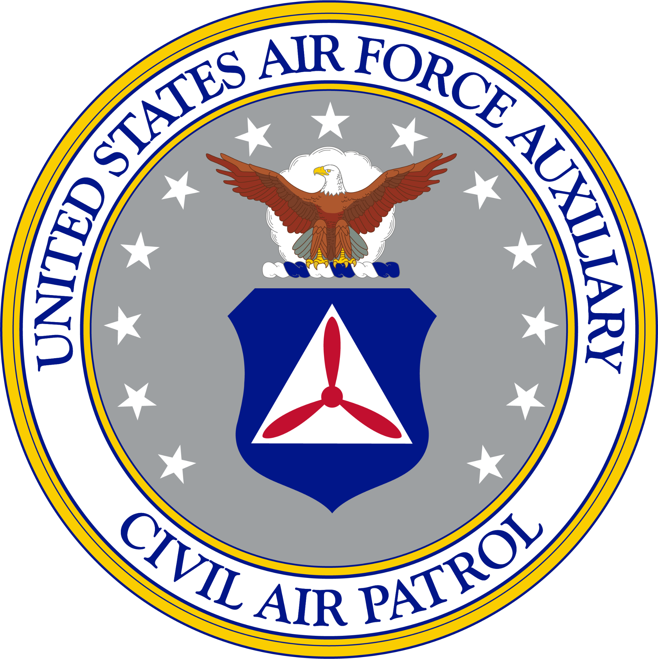
HEADQUARTERS MINNESOTA WING CADET ADVISORY COUNCIL
CIVIL AIR PATROL
UNITED STATES AIR FORCE AUXILIARY
6275 Crossman Lane
Inver Grove Heights MN 55076

1 December 1941

MEMORANDUM FOR NORTH CENTRAL REGION CADET ADVISORY COUNCIL

FROM: MINNESOTA WING CADET ADVISORY COUNCIL

SUBJECT: Proposal to _______

- This is a sample format of the Civil Air Patrol (CAP) memorandum-style letter which may be used for proposals to the North Central Region Cadet Advisory Council or other correspondence. Aside from the body paragraphs, anything highlighted in gray must be changed to fit the details of your proposal.

- The most crucial aspect of any proposal is how detailed it is. Your proposal should clearly define the issue(s) and any suggested solution(s). Moreover, the details should be specific and to the point; do not be abstract or vague in any part of the proposal. Typically, real-world legal arguments and disputes are interpreted against the drafter of the document. In other words, if it could have been put into the proposal when it was drafted, and it was not, there is not much the drafter can do from a legal standpoint. Therefore, the more details you have that reach beyond face value of the argument you're trying to make, the more likely it is to help your case. Furthermore, if you are doing research or need to back up any claims you make, ensure that you provide the appropriate credible resources. Remember, the more detailed and fact-based your proposal is, the more likely it is to be accepted at higher echelons.

- As with any document you may draft in your educational, CAP, or professional career, spelling and grammar remain of utmost importance. Be sure you constantly edit and proofread work. Tactics like employing proper comma usage, expanding out contractions (unless they are possessive), using active voice, utilizing proper capitalization, etc., should be noted when editing and proofreading for grammar. Ask at least one other person to look at your document(s) before sending them out, or invest in an online proofreader.

- Refer to CAPP 1-2 (Pages 19-32) and/or AFH 33-337 for associated formatting items.

NAME, Rank, CAP
*Insert Squadron* *Primary/Alternate* Representative
Minnesota Wing Cadet Advisory Council

